

# Introduction

The objective of this report is to document the analysis and findings of a dataset containing data released by Yelp (the business listing and crowdsourcing review company).



This data is inclusive of reviews, business details that the reviews relate to, users who submitted the reviews, tips submitted by users, check-ins submitted by users and photos taken and submitted by users.

In addition, financial as well as demographic data will be used to enrich the analysis.

The main tasks that were worked on as input to this report are:

1. Data Exploration, Quality Management and Transformation – to gain an understanding of the data attributes, to perform quality management checks and to conduct initial transformation on the source datasets.
2. Integration and Preparation – to integrate data from the source datasets into a larger combined dataset containing all required features, and then to prepare the integrated data for further analysis
3. Analysis and Geographic Visualization
4. Text Mining for sentiment analysis, authenticity analysis and topic modelling.
5. Forecasting to predict future counts, as well as the prediction validity.
6. Comparative analysis to determine how individual businesses are performing in relation to other similar businesses.
7. Results – describe what was found during the analysis.

# Analysis and Models

## About the Data

### Source Data

Data was sourced from three different places:

1. Yelp Data as sourced from the Yelp Dataset challenge website. This came in the form of a zipped file that contained 6 different JSON format datasets. The datasets contained the following data:
   * Reviews
   * Businesses
   * Tips
   * Checkins
   * Users
   * Photos
2. Dunn and Bradstreet Hoovers (DBH) business data; for restaurants in Arizona and Nevada
   * This data was selected and downloaded from the Dunn & Bradstreet Hoovers online business dataset
3. US Census (2010)
   * This data was obtained from the US Census Bureau

The below figure shows the conceptual data model that describes the data we obtained:

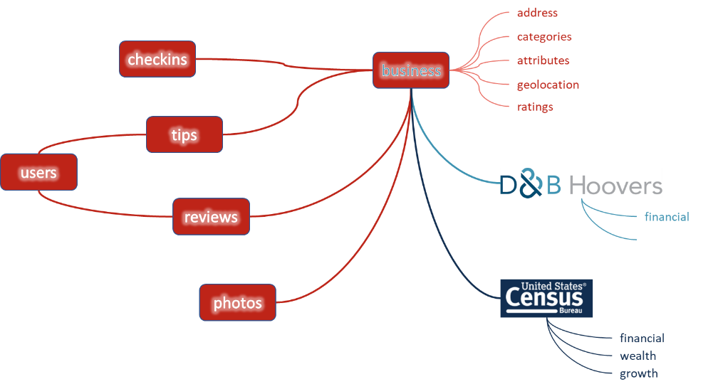

The eight sets of data (6 yelp plus DBH plus Census) are described below:

#### Yelp - Reviews

This is the primary dataset that most of our analysis and modelling revolved around. The dataset type is record type and comprises 6,685,900 observations across 6 variables.

The attribute type of three of the 5 columns are nominal; and the other 1 attribute was numeric.

Data was in JSON form, sample of two rows as followed:

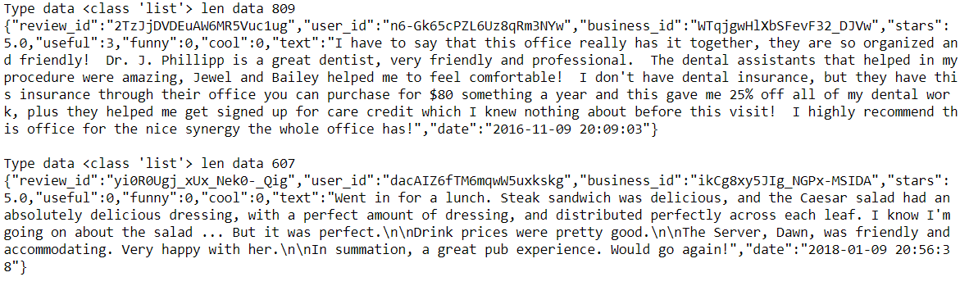

Due to the size of this dataset, the data had to be read and processed on an observation by observation basis. It was NOT possible to use standard JSON handlers to parse the dataset in one go.

A sample of 1 observation of the data parsed out is given below:

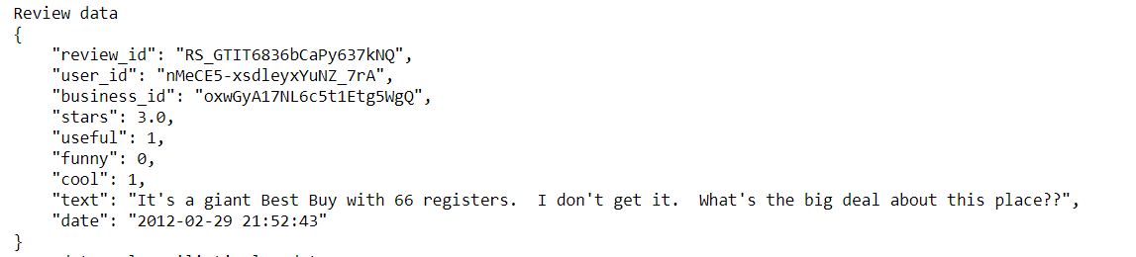

#### Yelp Businesses dataset

This is the dataset that was used to pick which businesses are of interest. The dataset type is record type and comprises 192.609 businesses across 14 variables.

A sample of raw data for 1 business is given below:  


And this translates into a more meaningful form as follows:

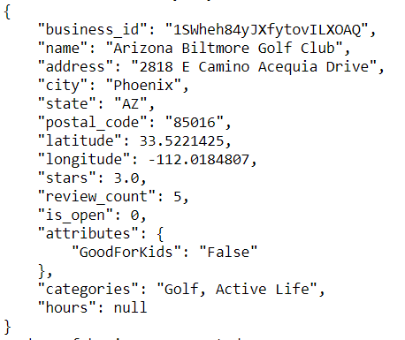

From an analysis of count of business by state, the following bar chart is produced:

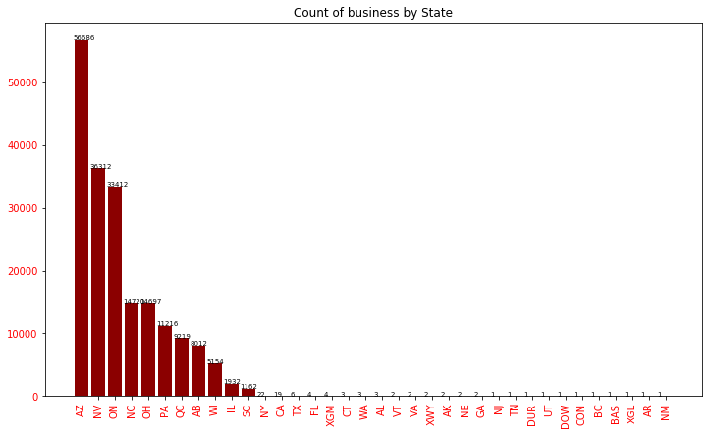

In addition to looking at business by state, businesses were also examined by category of business. The chart below shows how many businesses there are in each category. 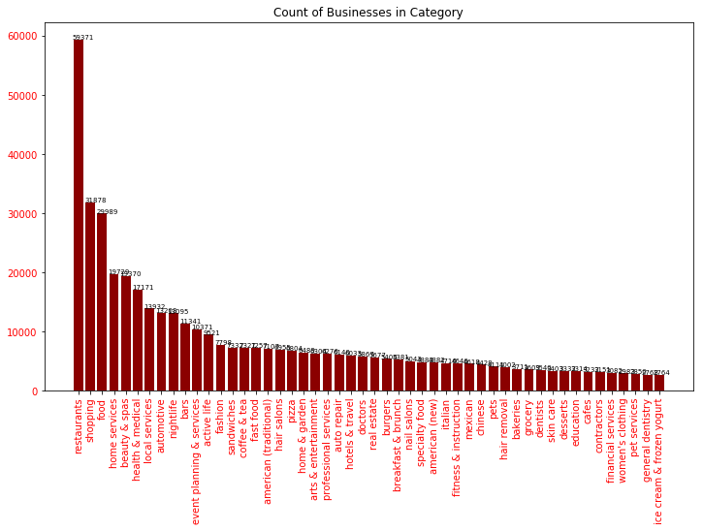

The attribute type of eight of the 14 columns are nominal; and the other 6 attributes are numeric.

Source data is in JSON form,

#### Yelp Users dataset

This is the dataset that most of our analysis and modelling revolved around. The dataset type is record type and comprises 1,637,138 observations across 22 variables.

Source data was in JSON form

A sample of raw data for 1 user is show here:

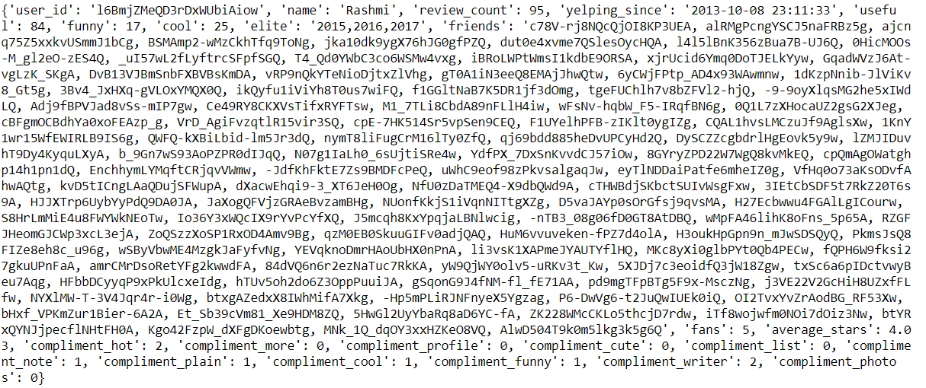

This parses out into the data shown below:

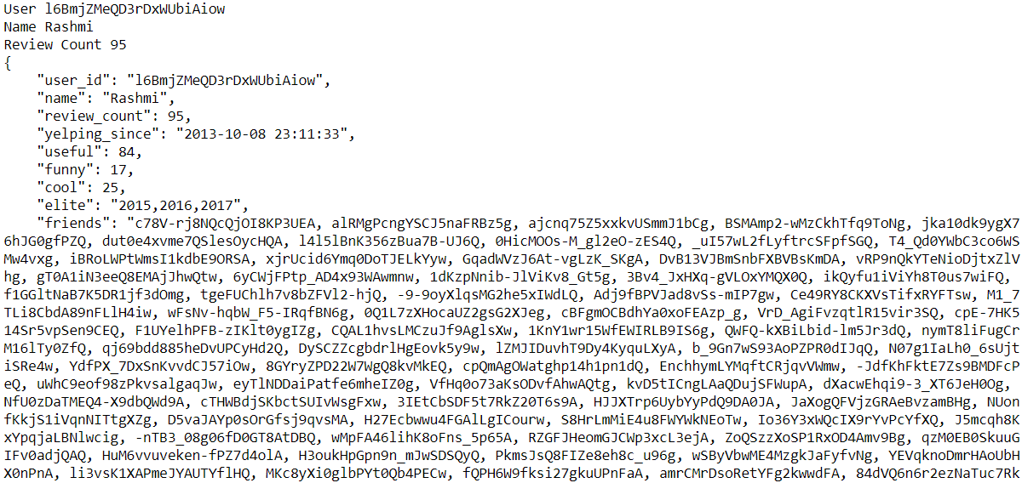

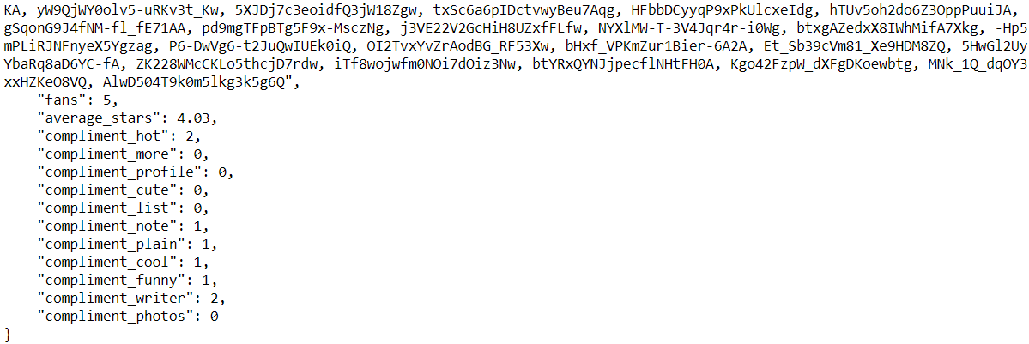

Data attributes on the Yelp Users dataset, in alphabetical order, are:

|  |
| --- |
| average_stars |
| compliment_cool |
| compliment_cute |
| compliment_funny |
| compliment_hot |
| compliment_list |
| compliment_more |
| compliment_note |
| compliment_photos |
| compliment_plain |
| compliment_profile |
| compliment_writer |
| cool |
| elite |
| fans |
| friends |
| funny |
| name |
| review_count |
| useful |
| User_id |
| yelping_since |

#### Yelp Tips dataset

This is the dataset that contains user tips about the specific business. The dataset type is record type and comprises 1,223,094 observations across 5 variables.

The attribute type of three of the 5 columns are nominal; and the other 1 attribute was numeric.

Source data was in JSON form.

A sample of 1 observation in raw form is:



This translates into a more readable form as follows:

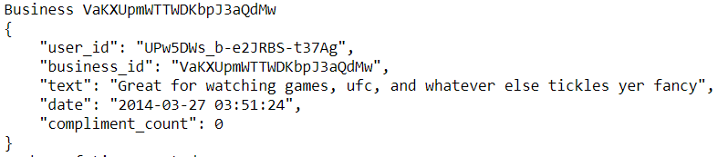

The data attributes on the tips dataset are:

|  |
| --- |
| user_id |
| business_id |
| text |
| date |
| compliment_count |

#### Yelp Check-ins dataset

This is the dataset that tracks when a user checks in to a business. The dataset type is record type and comprises 161,950 observations across 2 variables.

A sample of raw data for 1 user is given as follows:



And is transformed into a more meaningful set like this:



The attribute type of one of the 2 columns is nominal; and the other 1 attribute is numeric.

Source data is in JSON form.

#### Yelp Photos dataset

This is the dataset that our photo analysis was used for. In reality, the JSON dataset is an “index” dataset, that is of record type and comprises 200,000 observations. What this does is provide access to a set of photos, each of which is referenced via a photo_id that exists in the index file.

A sample of the raw data for 1 photo record is shown here:



And it expands as follows:

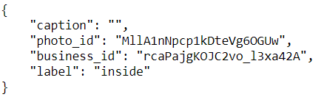

The attribute type for all 4 photo index columns are nominal.

This photo index acts as a pointer to photo “MllA1nNpcp1kDteVg6OGUw.jpg” in the image dataset.

A sample of nine images in the image dataset are shown below:

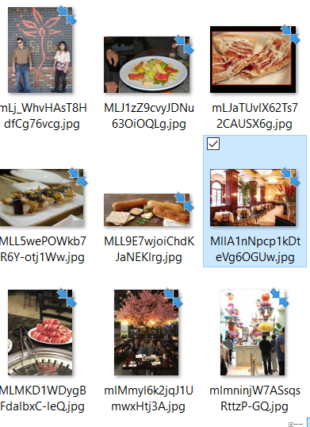

And the image for the photo corresponding to the data shown above is shown here:



Source data of the photo index file is in JSON form; format of the photo is in .jpg form.

#### D&B Hoovers financial dataset

The D&B Hoovers Financial dataset was obtained from the online catalog, where all business in Nevada and Arizona that are classified as restaurants were extracted. The dataset type is record type and comprises 27,524 observations with multiple financial and business variables.

A sample of the data is given below:

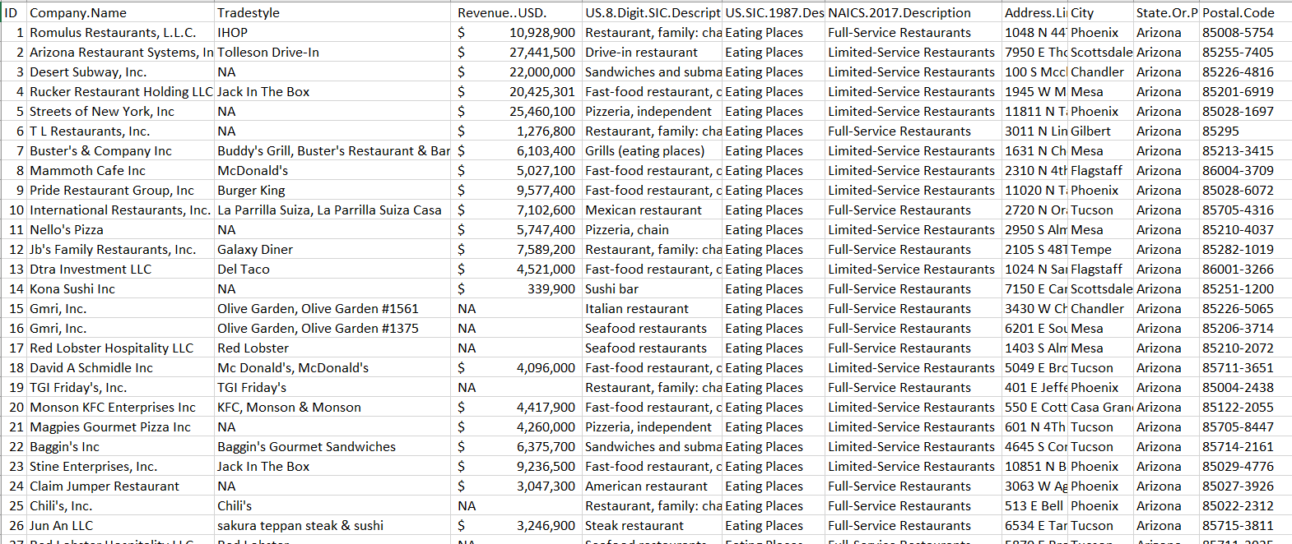

Source data is in excel form.

#### 2010 Census dataset

The intention was to use the census data to enrich our review dataset. The dataset type is record type and comprises 1,622,831 observations across 6 variables.

A sample of the data is given as follows:

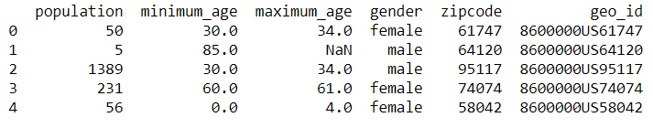

Figure 1:Sample Census 2010 Population data by zip

This was summarized by zipcode into 33,119 observations with attributes as follows:

* Zipcode
* Population count per zipcode – with descriptive statistics below.

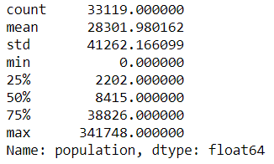

Figure 2: Descriptive stats for Population 2010 by zipcode data

* Average Income per Zipcode

Using this 2010 census data, we conducted analysis to determine some basic demographic data about the states and cities that we are interested in.

##### Average Income By State

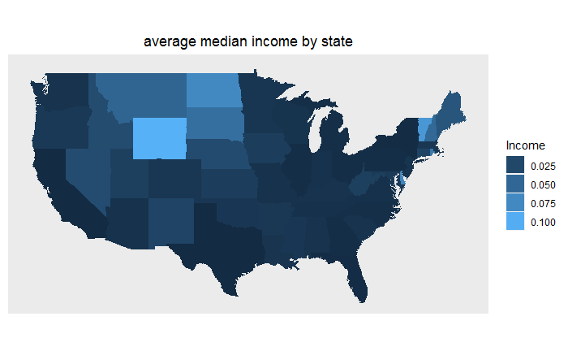

It can be seen from the above that the average income for both Arizona as well as Nevada is on the lower end of the average income by state scale.

##### Population by State

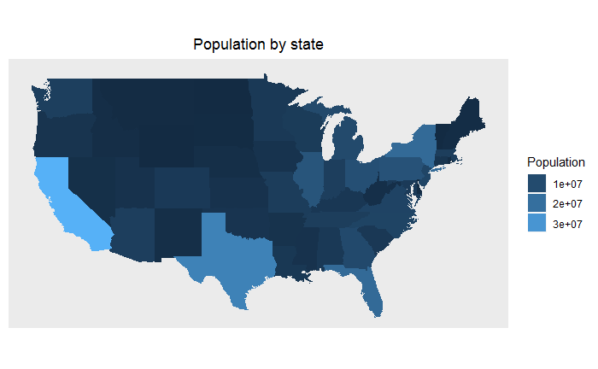

It can be seen from the above that the population for both Arizona as well as Nevada is on the lower end of the population by state scale.

##### Zipcode density

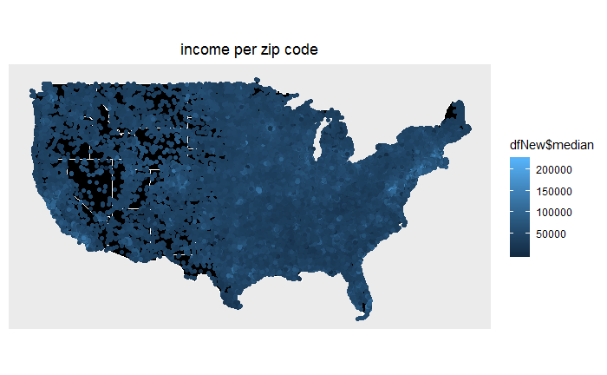

It can be seen from the above that zipcode areas are not as dense in the Arizona and Nevada states. This is indicative of a population that is not as dense.

##### Zipcode Density

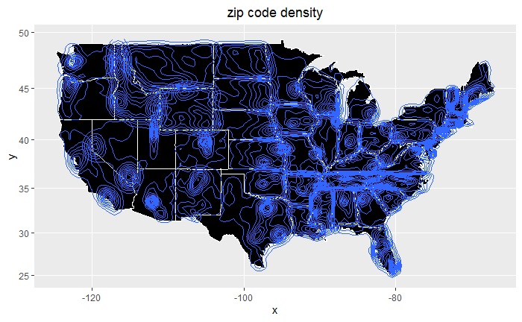

It can be seen from the above that zipcodes are not very dense in both Arizona as well as Nevada. This is indicative of a reduced population. What can be seen is concentration areas around Las Vegas, Nevada as well as Phoenix, Arizona. Both large cities.

##### Average Income by zipcode around Las Vegas

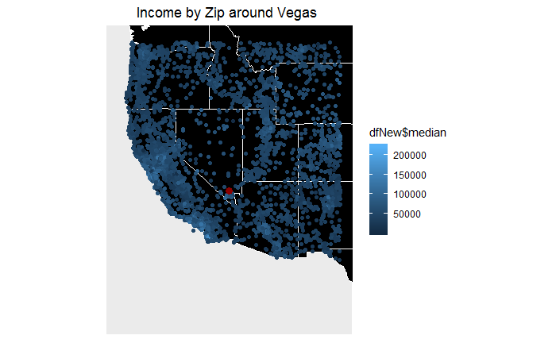

It can be seen that the average income ins zipcodes around Las Vegas is greater than those for the rest of Nevada.

##### Average Income by zipcode around Phoenix

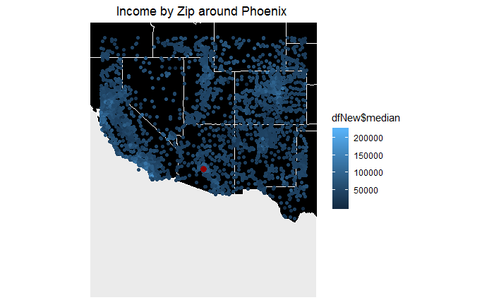

It can be seen that the average income by zipcode for the area around Phoenix is greater than that for the rest of Arizona.

#### Model Review Data

The model review data was obtained from an IST707 Data Analytics Project. This data contains 92 movie reviews, each with both a Sentiment as well as an Authenticity label. We viewed this as our Model Review data. This data was used to train our Sentiment and Authenticity models, after which we used the trained model to classify our Yelp reviews for sentiment and authenticity.

#### Missing Data

A cursory check was conducted to see whether any data was obviously missing. No issues were observed.

### Quality

Verifying the quality of data of data in these 9 datasets (6 from yelp, plus 1 from DBH plus 1 from 2010 census plus the Review Model) is not an easy exercise, because no quality rules were provided.

Basic quality checks that were performed were:

1. Ratings review – all reviews came with ratings that fitted the 1-star to 5-star model.
2. Yelp cross dataset linkage - All the yelp data was tied together via indexes provided: business_id, review_id, user_id and photo_id appear correct across all 6 yelp datasets.
3. Zip codes on the census data tied together with zip codes on the yelp business datasets.
4. There is no obvious missing data.
5. There is no obvious NA data.

### Transformation and Filtering

Due to the number of observations in the review data, as well as the difficulty working with 6MM observations, categorization and analysis was conducted to determine how the data could be partitioned. The following summary analyses were conducted:

1. Top 10 Business Categories – by business count.
2. Top 10 Cities with the Most Businesses.
3. Top 30 Restaurants in Arizona – by reviews.
4. Top 30 Restaurants in Nevada – by reviews.

Top 10 Categories of Business by business count:

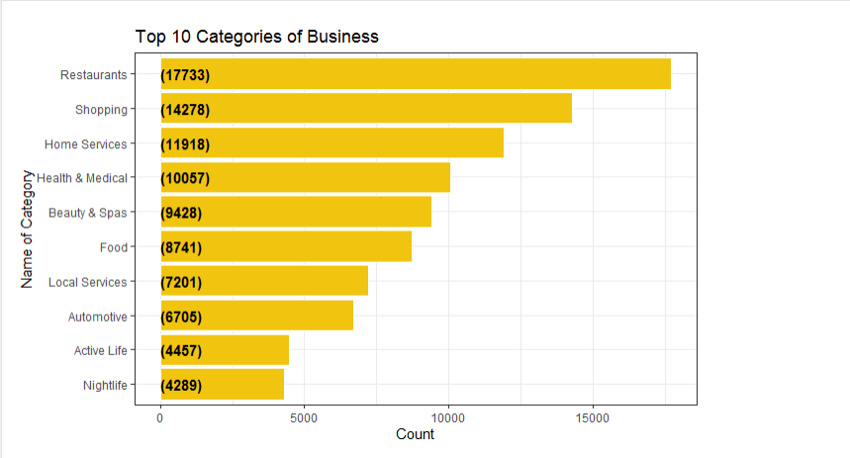

Top 10 cities in Arizona and Nevada where customers review count is maximum:

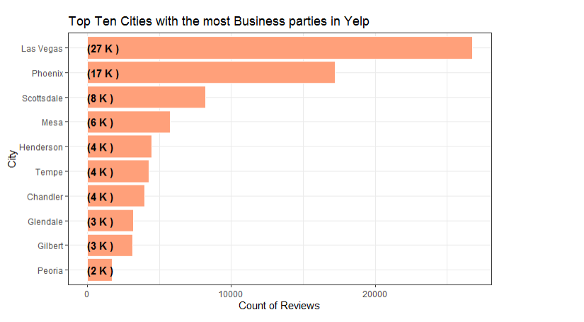

Location of Top 30 Restaurants in Nevada based on customer review count

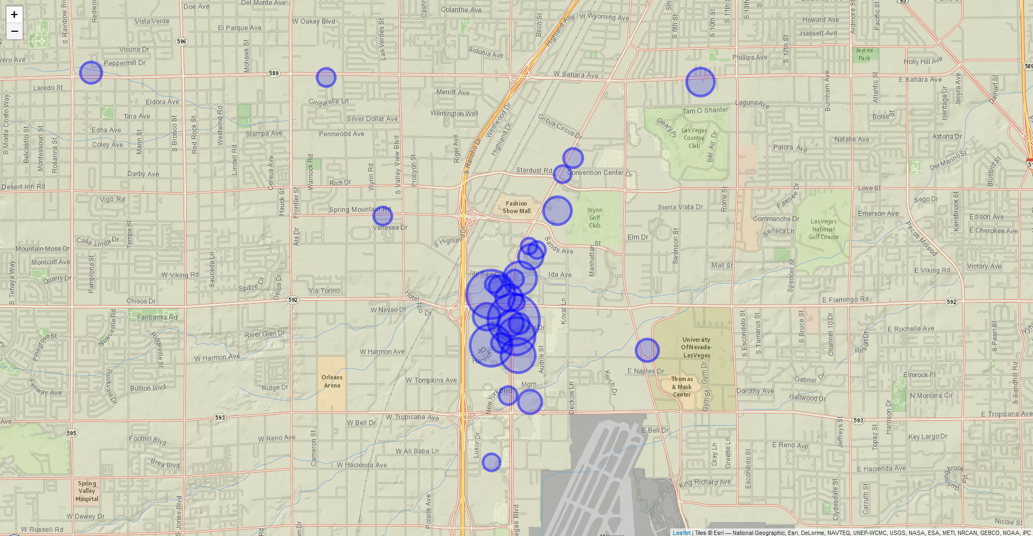

The above picture shows that Las Vegas BLVD has the single largest concentration of restaurants for food lovers in Nevada.

Location of Top 30 Restaurants in Arizona based on customer review count

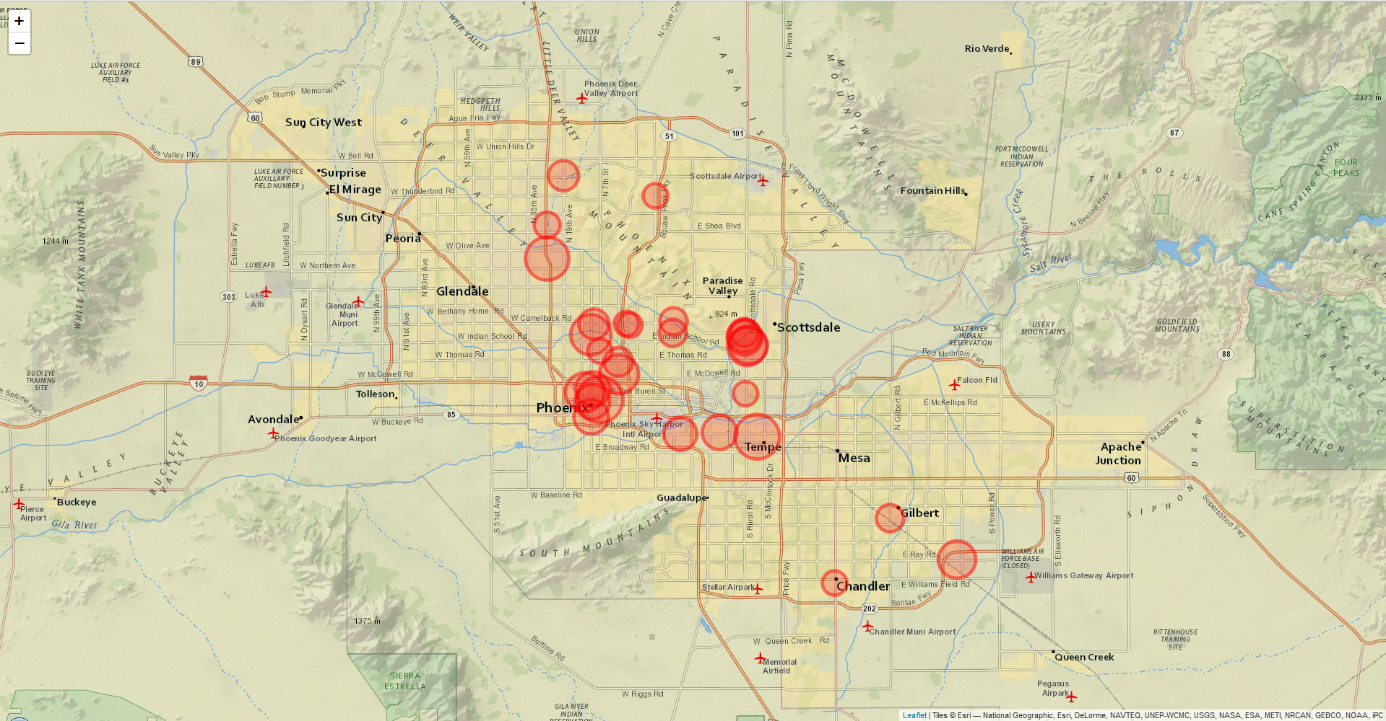

The above picture shows that Phoenix, Tempe and Deer Valley have the greatest concentration of restaurants in Arizona.

From the various categorization and analyses that were run, (the four above plus those that were run during the initial data analysis) it was decided to concentrate on reviews for business in Arizona and Nevada that are in the top 5 business categories. Categories selected were (1) Restaurants, (2) Shopping, (3) Food, (4) Home Services and (5) Beauty Spas.

The count of business selected, by category, is given in the table below:



Subsequent to selection of the relevant businesses, all other subsets were filtered to represent the businesses selected. This brought the observation counts for the Yelp data down, as shown below:



The selection and transformation per dataset is further described in the sections below:

#### Yelp Users Filtering

Users were selected and analyzed based on reviews they gave for the businesses of interest.

Given that there are 19,122 businesses of interest, with 1,042,847 reviews given by 455,680 users; the descriptive stats of count of reviews per user is shown as follows:

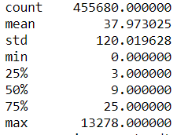

With a corresponding boxplot:

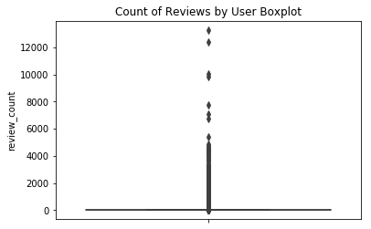

And the Top 50 reviewers are shown here:

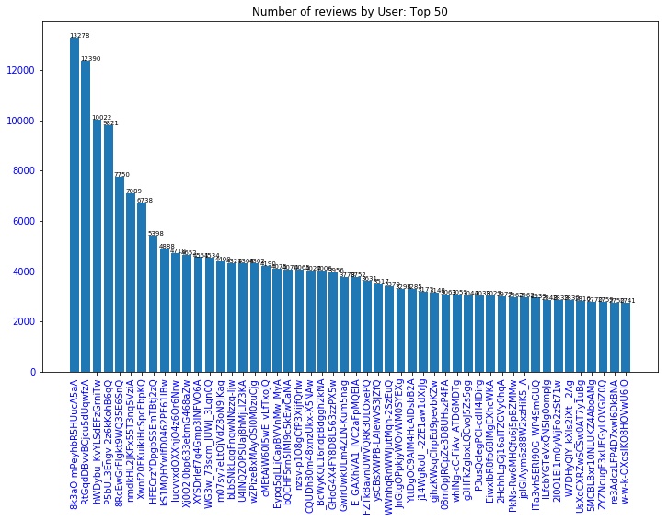

#### Yelp Tips dataset

Based on the data attributes on the Tips dataset, filtering for the purposes of this analysis can be done in one of two different ways.

Way 1: Filter by business_id. When tips are filtered by business, the count of tips selected was 219,946 tips. This is a relatively simple selection process because the business are first filtered by state and category, and the then tips are filtered based on the subset of businesses.

Way 2: Filter by user_id. When tips are filtered by user_id, the count of tips selected was 721,253. This is a more convoluted filtering process which accounts for the difference in tips counted. The path is (1) our selected business -> (2) our selected reviews -> (3) our selected users -> (4) our selected tips.

For subsequent analysis including tips, the tips by business subset was used.

### Integration

The approach that was taken to integration was to rely on the Yelp identifiers to integrate the Yelp datasets that are of interest:

1. Our Yelp Businesses will become the master dataset.
2. Our Yelp Reviews links to Our Yelp Businesses via business_id.
3. Our Yelp Photos links to Our Yelp Businesses via business_id.
4. Our Yelp Users integrates to Our Yelp Reviews via user_id.
5. Our Yelp Checkins integrates to Our Yelp Users via user_id.
6. Our Yelp Tips integrates to Our Yelp Users via user_id.

#### D&B Hoovers Financial dataset integration

It became apparent that integrating businesses on the Financial dataset with those on the Yelp business dataset was not practical, as the criteria for what was considered a Restaurant in the D&B Hoovers dataset was completely different to that on the Yelp business dataset.

As an example, the Bacchanal Buffet (one of the most reviewed restaurants in Las Vegas was listed on the Yelp data as being at 3570 S Las Vegas Boulevard, Las Vegas, 89109; whereas there is NO Bacchanal Buffet on the D&B Hoovers list. The Restaurants that are listed at this address on D&B Hoovers are:

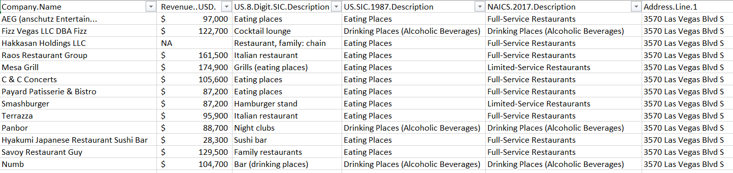

It should be note that the Bacchanal Buffet is a restaurant in the Caesars Palace resort.

As a second example, the Gordon Ramsay BurGR restaurant was also examined, with the same results. No ability to match across datasets. As a result of this, we did not use the Financial dataset for subsequent analysis.

## Model1: Forecasting Reviews

FB Prophet was used to forecast the number of reviews we would likely receive for AZ and NV Restaurants for 2018 and 2019, given 11 years of actual reviews from 01/01/2007 thru 12/31/2017. The black dots show actual count of ratings received by month for the 11-year period. The blue line shows the forecast, and the blue shaded are shows the lower and upper expected boundaries.

As can be observed, seasonality likely comes into play in the November month each year.

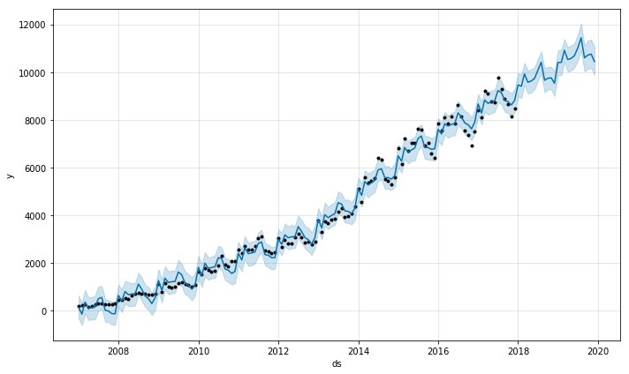

The histogram below shows the distribution of data over the temporal period, and the line shows the density of the data. From this we can tell that the average over the time period is approximately 3000 reviews per period. The density uses the “kde” function. In statistics, kernel density estimation (KDE) is a non-parametric way to estimate the probability density function of a random variable. Kernel density estimation is a fundamental data smoothing problem where inferences about the population are made, based on a finite data sample.

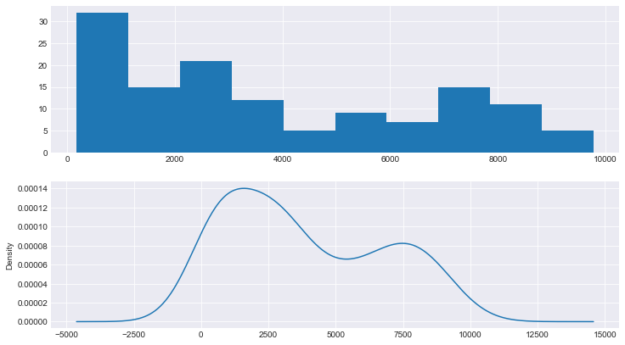

The next step in analyzing the data is to do a boxplot, which visually depicts descriptive statistics for review per year. There are a few outliers, but nothing that shows a significant difference from period to period. Upward trend is the same as what is shown on the forecast chart.

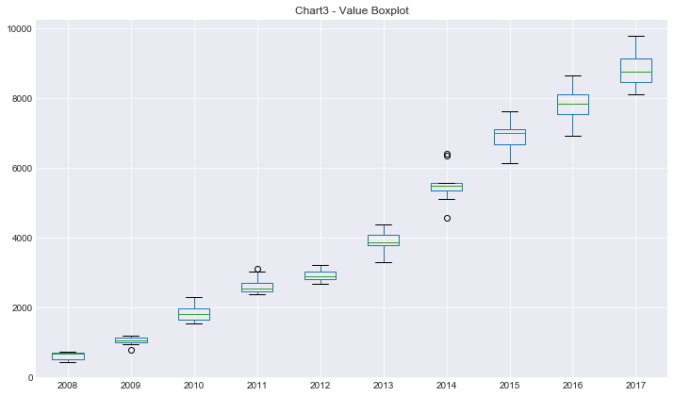

The ADF function was used to determine whether seasonality is at play, and as a result of a negative number returned, we see that it is.

ADF Statistic: -1.813581

p-value: 0.373740

Critical Values:

1%: -3.488

5%: -2.887

10%: -2.580

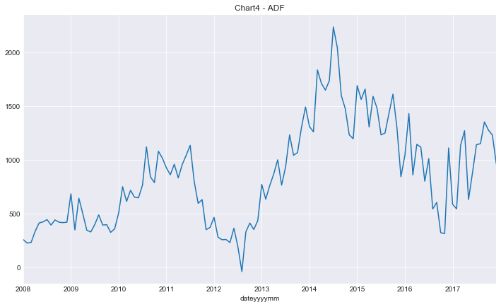

As a result of this, a first differencing was done to try and remove the seasonality from the data (to normalize it). Even though this was done, the chart still shows some spikes year over year which represent the differences.

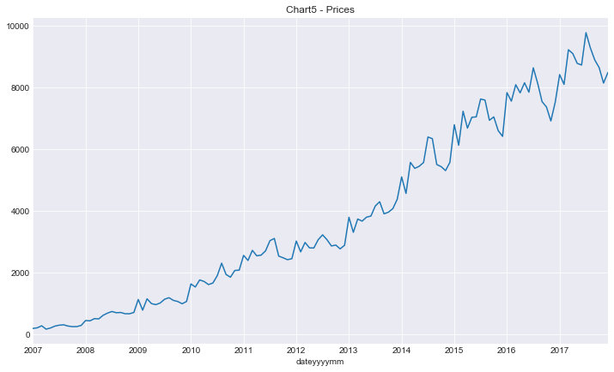

The normalized time series is then used to create the autocorrelation plot as well as the partial auto correlation plots, from where we can determine how to make a model using the Box-Jenkins

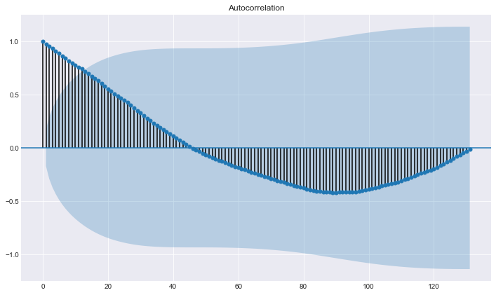

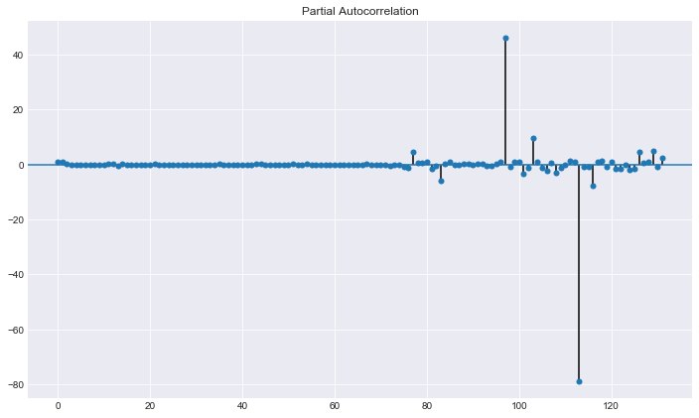

The original time series data was used as the input to Prophet (the forecasting model). The trend chart below shows an increasing trend over time, the yearly chart shows that seasonality is at play in August and November.

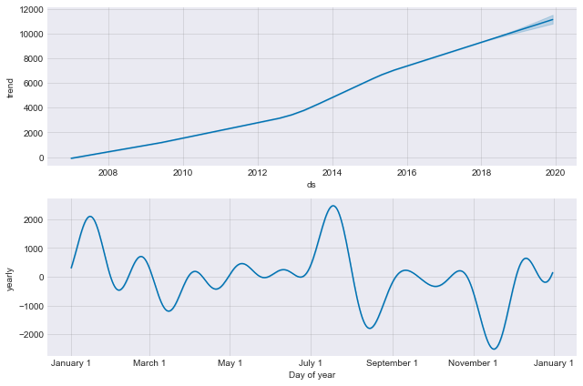

Lastly, to verify the output of the prophet model, the R-squared, MSE and MAE were run to confirm the accuracy of the output.

R-squared 0.9927276585528302

MSE 60059.42880893668

MAE 205.3873928157873

The number given above shows that we can rely on the output of the forecasting model

To complete this exercise, a forecasting model was run for each of the rating level (1-star thru 5-star) as shown in the following spaghetti chart. This is the next level of detail from the first chart shown in this model.

What is interesting to note is that 2013 appears to be a pivotal year. Up to that point, the trend of 1-star thru 5-star appears to be the same. From 2013 onwards, the 5-star ratings increased dramatically; and the 1-star ratings followed an increasing trend. As a separate exercise, it would be interesting to understand what the changes are in what people thought about giving star ratings from 2013 onward.

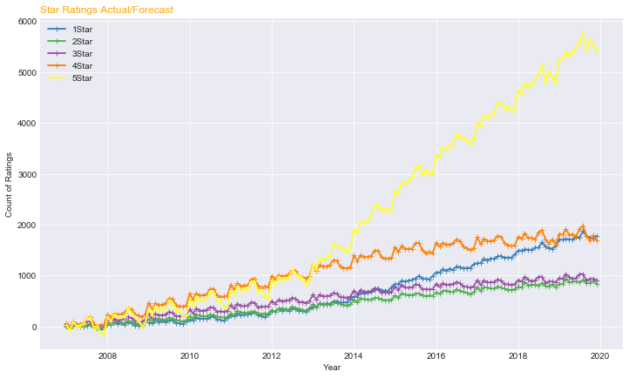

## Model 2: Text Mining to Determine Review Sentiment

Sentiment analysis is a type of text research that involved the use of statistics, natural language processing and machine learning to identify and extract subjective information from text, for instance, a reviewer’s feelings, thoughts, judgments, or assessments about a topic.

Our Review Sentiment Analysis followed a train and test approach, as follows:

1. Using 70% of the Review Model data, together with the Sentiment label, we trained our model for Sentiment Analysis.
   1. We trained using SVM as well as Random Forest
   2. We picked the more accurate training model for classification
2. Using the remaining 30% of the Review Model data, we verified that our trained model classified for sentiment correctly.
3. Once we verified the trained model, we classified all Yelp reviews of interest using the previously trained model.

Below is the distribution of yelp review sentiment (positive or negative) based on the reviews corresponding star rating.

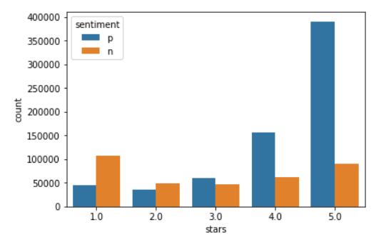

## Model 3: Text Mining to Determine Review Authenticity

Authenticity analysis is the evaluation of a set of text, to determine whether the text is truthful or whether it is a lie.

Our Review Authenticity Analysis followed a train and test approach, as follows:

1. Using 70% of the Review Model data, together with the Authenticity label, we trained our model for Authenticity Analysis.
   1. We trained using SVM as well as Random Forest
   2. We picked the more accurate training model for classification
2. Using the remaining 30% of the Review Model data, we verified that our trained model classified for authenticity correctly.
3. Once we verified the trained model, we classified all Yelp reviews of interest for authenticity using the previously trained model.

Below is the distribution of yelp review authenticity (true or false) based on the reviews corresponding star rating.

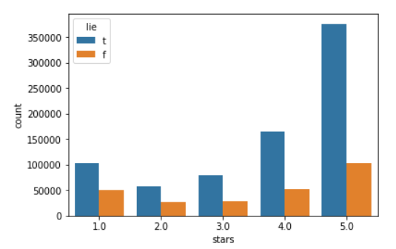

Below is the Word cloud for positive review with 5 stars

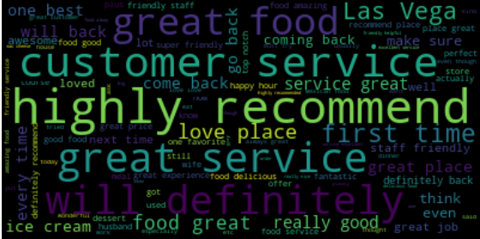

Where ‘Great’, ‘service’, ‘recommend’, ‘Will’, ‘definitely’ e.t.c. are significant word.

Below is the Word cloud of the negative review with 5 stars

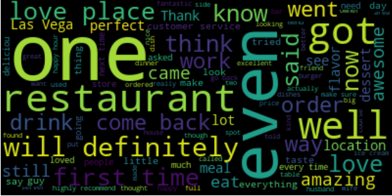

Where ‘One, ‘even, ‘recommend’, ‘Will’, ‘definitely’, ‘well’ e.t.c. are significant word.

## Model4: Review Topic Modelling

Topic modeling is a type of statistical model for discovering the abstract topics that occur in a collection of documents. Latent (which means hidden or unknown) Dirichlet Allocation (LDA) is an example of topic modeling and is used to classify text in a document to a topic which is the most popular and widely adopted in practice. Other types of topic modeling algorithms are Latent Semantic Analysis (LSA) and hierarchical Dirichlet process (HAD).

Topic modelling was used to separate the reviews of interest into topics for further review. The three major topics that were derived from user reviews are:

1. Reviews about the **food**
2. Reviews that are about the quality of **service**
3. Reviews about the user **experience**.

The three figures below are samples of word distribution for each of the topics that were identified.

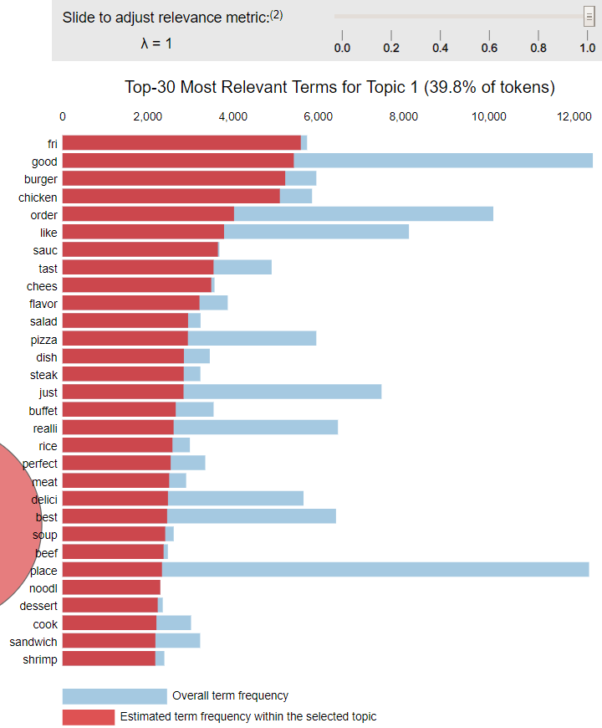

This first figure shows the top 30 most relevant terms for the Food topic.

As can be seen, words relating to food are prevalent in the list.

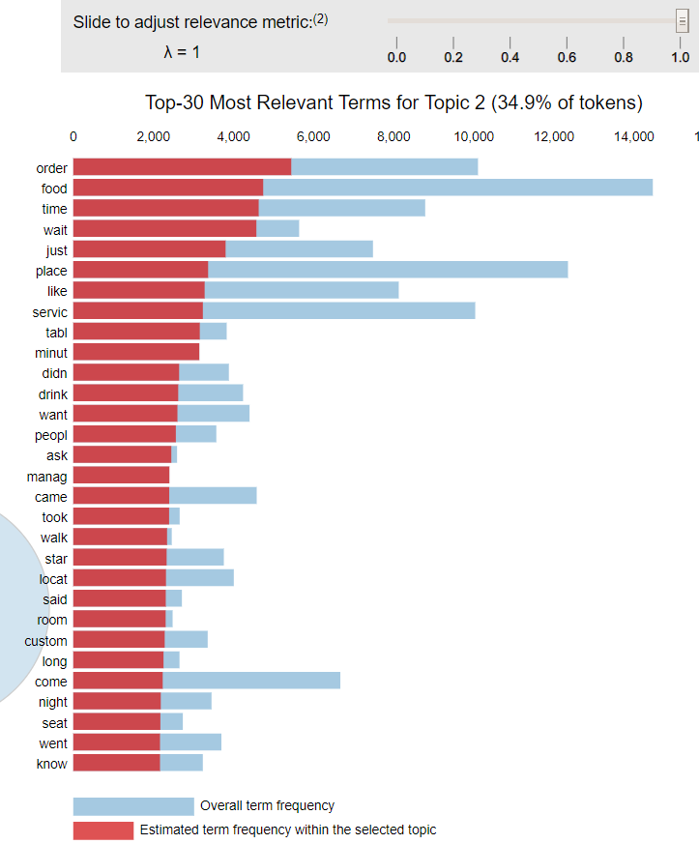 This second figure shows the top 30 most relevant terms for the Service topic.

As can be seen, words relating to service are prevalent in the list.

Eg

Order

Time

Wait

Place

Like

Minute

Didn’t

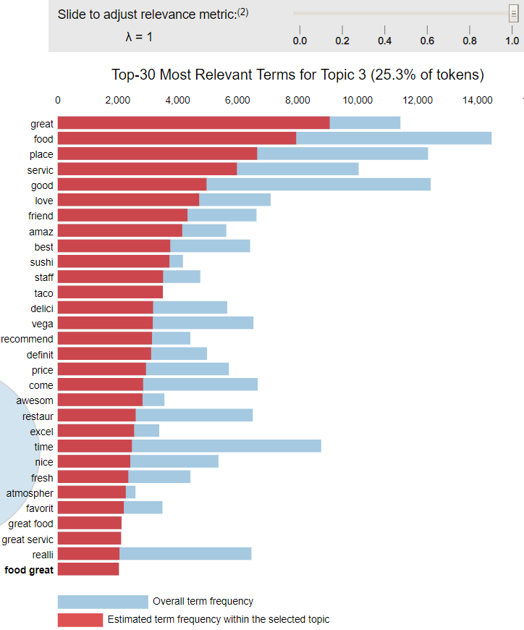This third figure shows the top 30 most relevant terms for the Experience topic.

As can be seen, words relating to the user experience are prevalent in this list

Eg

Great

Good

Love

Friend

Best

## Model5: Tip Sentiment Analysis

A Sentiment Polarity Analysis was run on User Tips. For each tip, a sentiment polarity value was derived in the range -1 thru 1. The closer to 1 the polarity is for a tip, the more positive the sentiment. The closer to -1 the polarity is for a tip, the more negative the sentiment is. A polarity of 0 means the sentiment is neutral. The histogram below shows the polarity rating for all tips. With a mean value of approx .25, it shows that in general tips have a positive sentiment.

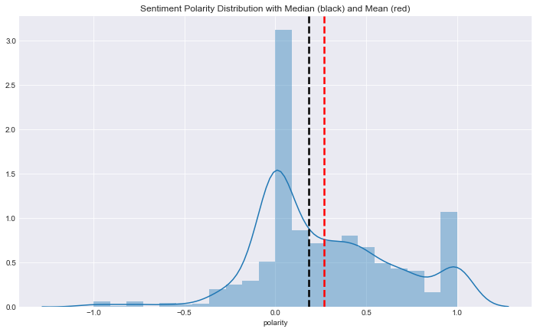

As an example, the top 15 tips for Bacchanal Buffet are shown below:

Best buffet in town!!

Best Vegas buffet with tons of variety!! Go, you won't regret it!!

Best place to eat brunch in Vegas Save room for all the delicious food.

Best buffet as of March 2014. Beats Wicked Spoon and others.

Awesome food. A must stop when in Vegas.

Best buffet in Vegas!

This places is the best buffet in LAS VEGAS

Awesome! Gotta go here!

Best buffet on earth!!!

No wonder why USA just named this place Best Buffet! You have to go!

Best buffet I had in Las Vegas.

I can't even explain how great this place is!! Recommended!

Halibut!! Awesome $42.98 per person before tax and tip

The best!!!

## Model6: Photos with People

Using photos from Bacchanal Buffet as the test set, the objective was to identify photos of people.

Using code from the OpenCV (Open Source Computer Vision) library, 823 photos were scanned to see which were identified with people in the photos.

For the first iteration, using a scaling factor of 1.2, 47 photos were returned as having faces included. Looking thru the photos below, this is obviously incorrect.

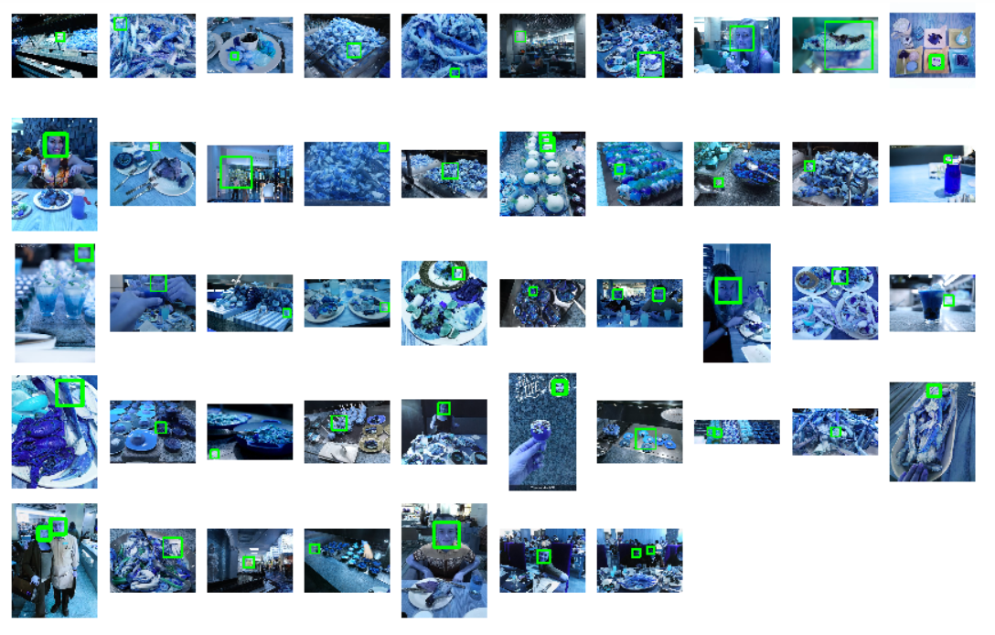

For the second iteration, using a scaling factor of 1.4, 7 photos were returned as having faces included in the picture (see below). As can be seen, this requires further refinement. The top left photo does not have a face in it, but was interpreted that it does. What is interesting to note is that 1 photo in the earlier analysis that DOES include a face was excluded from this second iteration!!! More work is required to fine tune this facial recognition system.

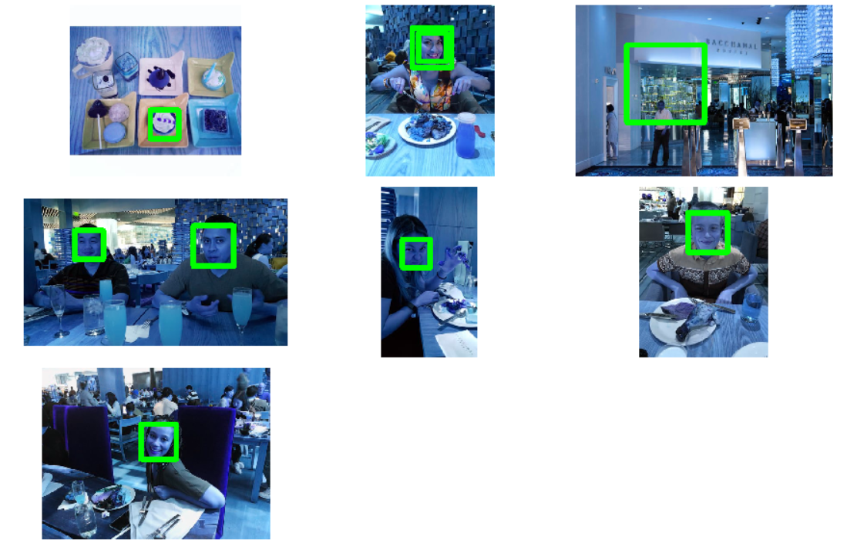

# Results

## Observation: Review Forecasting shows Seasonality

Forecasting of the total review count shows that seasonality is a factor that must be considered. As can be seen, the trend chart shows an upward trend for review counts – which is good – and implies an upward trend in the number of visitors.

What the yearly (aka seasonality) chart shows is that the months of August and November have a lower review count, hence they also likely have less users reviewing these businesses – meaning that there is opportunity to improve the businesses over these times. Or to scale businesses back to accommodate this.

## Observation: Review Sentiment does not match star rating

The chart at left shows, by star rating, which reviews have sentiment that is considered positive and which are considered negative.

The first anomaly appears to be that with the sentiment of the 1-star reviews. This shows that about 1/3 of 1-star reviews have sentime that is considered positive.

The second anomaly is for 4-star reviews. This shows that about 1/3 of these reviews are considered negative.

The third anomaly is for 5-star reviews. About 20% of the 5-star reviews have wording that is considered negative.

What it is NOT possible to tell from this analysis is the quality of the user. We do not know who the user is, nor do we know what they represent. We do not even know whether they are a human or whether they are a bot.

## Observation: Review Authenticity does not match star rating

The chart at left shows, by star rating, which reviews have an authenticity rating that is considered true and which are considered false.

The first anomaly is that the 1-star, 2-star and 3-star ratings have approx 50% of their reviews considered false.

The second anomaly is that the 4-star and 5-star ratings have approx 25% of their reviews that are considered false.

What it is NOT possible to tell from this analysis is the quality of the user. We do not know who the user is, nor do we know what they represent. We do not even know whether they are a human or whether they are a bot.

## Observation: Seasonality is at play for Bacchanal Buffet

The Bacchanal Buffet restaurant is the restaurant in Las Vegas with the highest count of reviews in the Yelp dataset.

A full forecasting model was run for the Bacchanal Buffet restaurant. What it shows is that the Yelp review counts are increasing, and the forecast is increasing as well. What it also appears to show is that seasonality is at play. This requires further investigation.

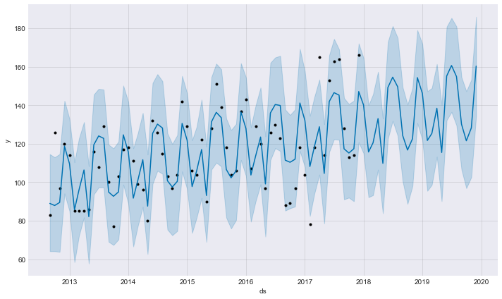

Looking at the trend chart below, it can be seen that the trend is an increasing trend, which support what is shown by the forecast chart above.

In addition, looking at the profile of the seasonality chart, it can be seen that the periods end-February, end-April, end-September and maybe August and November are all affected.

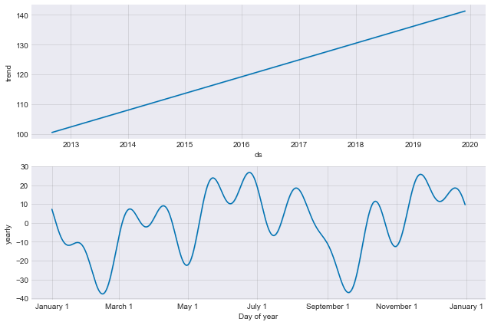

Lastly, the forecast for individual review ratings levels show the

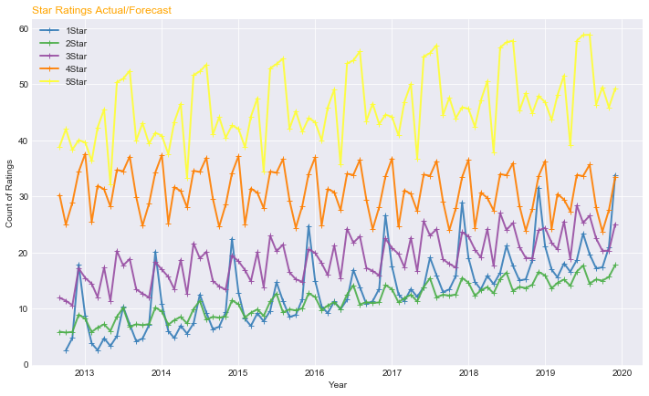

## Observation: Reduction in business at Gordon Ramsay BurGR

The Gordon Ramsay BurGR restaurant is the restaurant in Las Vegas with the second highest count of reviews in the Yelp dataset.

A full forecasting model was run for Gordon Ramsay BurGR restaurant, and it shows that reviews are declining.

The period for this analysis was reviews from 2012/01/01 thru 2017/12/31 actuals and 24 months forecast 2018/0101 thru 2019/12/13.

The forecast chart below shows a reducing review count, which is indicative of a business that is worsening.

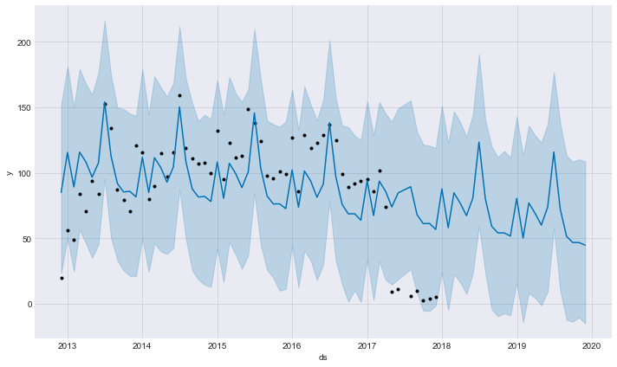

As can be seen by the trend chart (below), the forecast shows that the Yelp review count will continue to decrease over the next two years.

In addition, looking at the profile of the seasonality chart, it appears as if seasonality is at play here as well. The periods end-January, as well as August thru December appear to have reduced reviews – implying reduced business over this time.

What should be investigated is “what is the difference between June/July and all other months”.

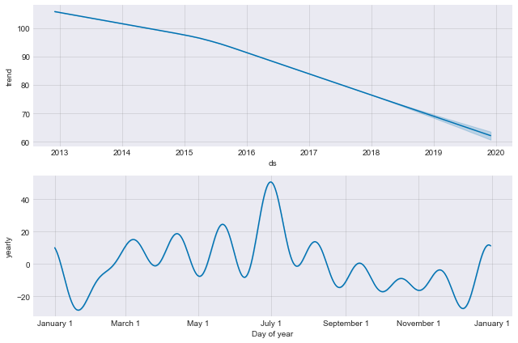

To complete this analysis, it would be worthwhile to identify the behavior of users at the time of giving reviews.

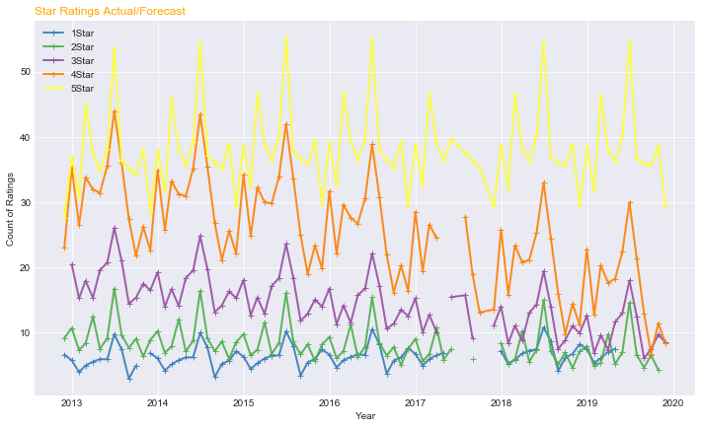

# Conclusions

## General

As can be seen throughout this report, analyzing the Yelp data provided a variety of topic areas that were used to conduct an analysis of crowd-sourced user reviews.

The analysis, including modeling, covered the following areas:

* Text mining to derive review sentiment analysis
* Text mining to derive review authenticity analysis
* Text mining to derive tip sentiment analysis
* Topic modeling of reviews to segment reviews
* Review count and rating forecasting
* Review seasonality analysis
* Photo analysis for photo segmentation
* Geo visualization for business selection

From this analysis, a number of observations were derived, including:

* Seasonality identification from forecasting
* Conflict between star ratings and sentiment
* Conflicts between star ratings and authenticity

The takeaways from this for geographic areas or business groups are:

* Social Media strategy can be enhanced by reviewing theses results
* Business cycles can be identified using these results
* Comparative behavior can be derived based on topic modeling

To conclude, there is a wealth of information contained in the Yelp dataset that allowed conclusions to be drawn from the analysis.

In addition, some of the analysis left some questions that require answers for further analysis.

Lastly, there is further analysis that can be conducted on the Yelp data that we did not cover:

* User
* Prediction of star ratings